**8 BIT DIVISION**

**EXPERIMENT 4**

**AIM:** To write an assembly language program to implement 8-bit multiplication using 8085 processor.

**ALGRITHM:**

1. Load the HL pair registers with address of memory location.
2. Move the first data to register B.
3. Move the second data to the accumulator.
4. Then compare two numbers for carry.
5. Subtract the content of Register B to the content of accumulator.
6. Then increment the value of carry.
7. Then check whether the repeated subtraction is over.
8. If the repeated subtraction is over then store the value of quotient and remainder in the given memory location.

**PROGRAM:**

LDA 8501

MOV B,A

LDA 8500

MVI C,00

LOOP: CMP B

JC LOOP1

SUB B

INR C

JMP LOOP

LOOP1: STA 8502

MOV A,C

STA 8503

RST 1

**INPUT:**

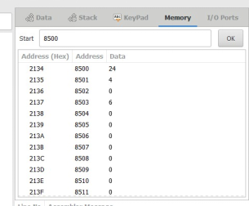

**OUTPUT:**

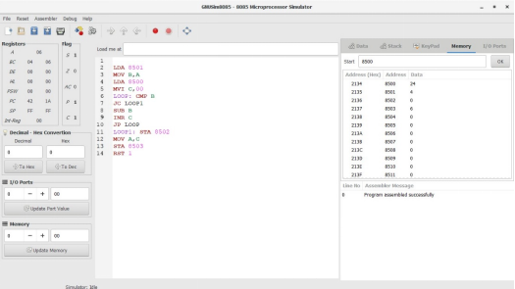

**RESULT:** Thus the program was executed successfully using 8085 processor simulator.